Civil war in Liberia

UNSC Resolution: | 866
Date of adoption: | 22-Sep-1993
Operative paragraph: | 11
Demand number: | 866,1111

Sarah-Myriam Martin-Brûlé

Wording of demand

cooperate fully in the safe delivery of humanitarian assistance to all parts of the country by the most direct routes, in accordance with the Peace Agreement

List of addressees of the demand

Government of Liberia, Liberian Peace Council, National Patriotic Front of Liberia, United Liberation Movement of Liberia for Democracy

Short-term compliance

Description of the addressee(s)’ conduct

“Human rights abuses continued throughout the country by all the warring factions. By mid-September, renewed fighting and attacks on relief workers and other noncombatants, including the capture by NPFL forces of forty-three U.N. observers and six NGO staff who were later released, had forced all relief organizations to recall their staff members to Monrovia. All the fighters continued to act with impunity in their territory, subjecting civilians to a range of abuses, from harassment and detention to arbitrary execution. For its part, the NPFL attacked civilians in its war against the LPC in the southeast, and in the inter-faction fighting that broke out in August. In October, UNICEF reported that about 500 orphaned children, who had been housed in the NPFL capital of Gbarnga, had been moved to Totota, near the battlefront, and were "starving and in grave danger."
“ULIMO also engaged in attacks on civilians, looting, and executions. On December 23, 1993, ULIMO attacked the United Nations base in Vahun in Lofa County: U.N. and nongovernmental organizations' vehicles were stolen, and their warehouses were looted. The U.N. was forced to evacuate all its staff, as well as eighty-two orphans.”

Human Rights Watch, Human Rights Watch World Report 1995 - Liberia, 1 January 1995, available at: http://www.unhcr.org/refworld/docid/467fca9b1e.html

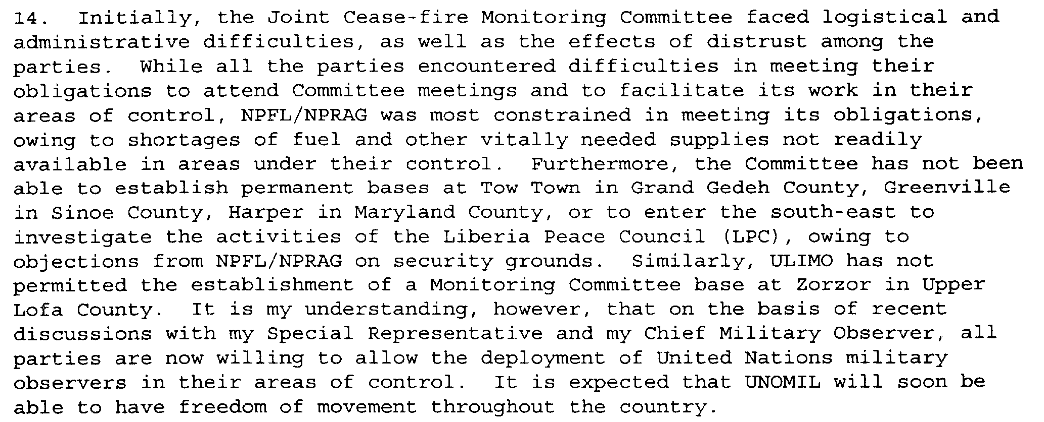
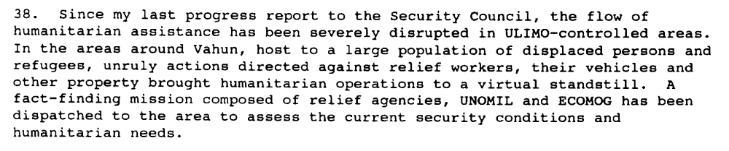
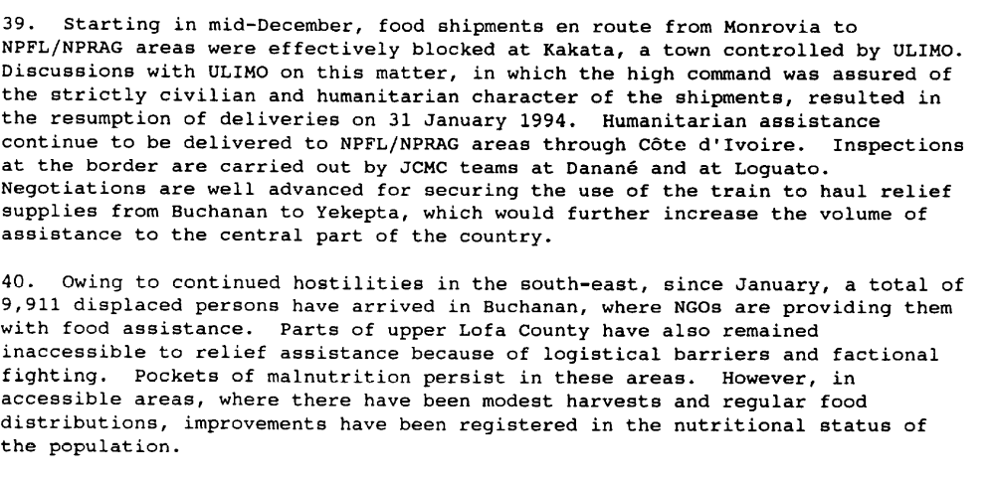

Report of the Secretary-General, S/1994/168, 14 February 1994

“In his report to the Security Council on 14 February 1994, the Secretary-General stated that the impasse in the implementation of the Cotonou Agreement had resulted from differing views among the parties on the date for the installation of the Transitional Government and the commencement of disarmament. He believed, however, that the remaining outstanding issues impeding the implementation were not insurmountable. The Secretary-General therefore urged the Liberian parties to make a renewed and determined effort to reach consensus and cooperate in good faith with UNOMIL and ECOMOG. He also urged the international community to contribute the necessary logistical and financial resources to both the existing and expanded ECOMOG troops in order to enable it to meet its obligations under the Cotonou Agreement. In order to enable United Nations agencies and non-governmental organizations to provide humanitarian assistance to all areas of the country, the Secretary-General called upon the parties to create the necessary conditions to ensure the unimpeded delivery of humanitarian assistance to all parts of Liberia”

UNOMIL
http://popp.gmu.edu/peace/unomil.html

Assessment

Short-term compliance
X No or marginal compliance (1) | Medium low compliance (2) | Medium high compliance (3) | Full or almost full compliance (4)

Considerations underlying the assessment

There was no compliance within the six months following the adoption of the resolution.

Medium-term compliance

Description of the addressee(s)’ conduct

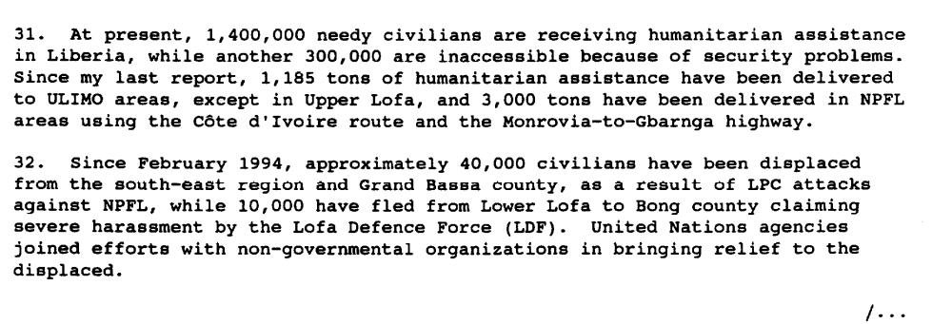
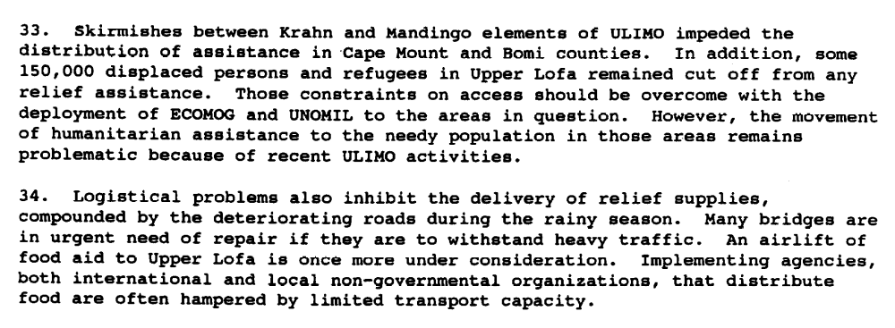
Third Progress Report of the Secretary-General on the United Nations Observer Mission in Liberia, S/1994/463, 18 April 1994

“The Secretary-General noted, however, that conflict between new armed
groups continued and that the influx of displaced persons was increasing. Humanitarian
assistance had also been severely disrupted in some areas.
(…)
“The Council, however, wishes to express its concern about the recent upsurge in
violence in Liberia and the related disruption of humanitarian relief shipments, to which the rise of new military groups and problems of military indiscipline among the existing factions have contributed. It deplores the consequent loss of life, destruction of property and the increased number of people that have since been displaced. The Council calls upon all Liberian parties to adhere strictly to the cease-fire agreement and to cooperate fully with the international relief efforts in order to put an end to the obstacles periodically impeding the delivery of humanitarian aid.”

Chapter 8, “Repertoire of the Security Council”
http://www.un.org/fr/sc/repertoire/93-95/CHAPTER%208/AFRICA/item%2005 -%20Liberia.pdf

At its 3404th meeting, on 13 July 1994, the Security Council included in its
agenda the report of the Secretary-General of 24 June 1994:

The Council expresses its concern about the increase in military activities being carried
out in violation of the general cease-fire and the consequent large-scale displacement of
persons and atrocities which have been committed throughout the country. The Council
condemns all those who initiate fighting and who violate international humanitarian law.
“The Council strongly deplores attacks on and the abduction and harassment of United
Nations and Economic Community of West African States Monitoring Group personnel in Liberia, as well as looting of United Nations and Monitoring Group property. It demands that such hostile acts cease forthwith.
“The Council urges the Liberian parties to take all necessary measures to ensure the
security and safety of Mission and Monitoring Group personnel, as well as of the personnel involved in relief operations, and strictly to abide by the applicable rules of international humanitarian law. It demands that all factions in Liberia extend full cooperation to organizations engaged in the delivery of humanitarian assistance.
(…)
“At its 3424 th meeting, on 13 September 1994, the Security Council resumed its
consideration of the situation in Liberia. After the adoption of the agenda, the President
(Spain) stated that, following consultations among members of the Security Council, he
had been authorized to make the following statement on behalf of the Council:
“ The Security Council strongly condemns the detention and mistreatment of forty-three unarmed military observers of the United Nations Observer Mission in Liberia and six staff members of non-governmental organizations, in flagrant violation of international humanitarian law as well as of the Cotonou Agreement (S/26272, annex). It demands that those responsible release immediately the detained personnel and return their property and that of the Mission and humanitarian organizations.”

Chapter 8, “Repertoire of the Security Council”
http://www.un.org/fr/sc/repertoire/93-95/CHAPTER%208/AFRICA/item%2005-%20Liberia.pdf

Medium-term compliance
X No or marginal compliance (1) | Medium low compliance (2) | Medium high compliance (3) | Full or almost full compliance (4)

Considerations underlying the assessment

There were no compliance with this demand within the two years following the adoption of the resolution.

Depth of demand

Assessment

Level of depth of demand
Low depth of demand (1) | X Medium depth of demand (2) | High depth of demand (3)

Considerations underlying the assessment

Given the anarchic context in which the parties found themselves, compliance with this demand would have made it significantly more difficult for some of the addressees to achieve victory. The looting and prey on United Nations and humanitarian personnel was used as a military strategy to gain power over the adversaries (deprive them of their civilian support base, send costly signaling of their intentions to win the war or to gain access/ control over a territory, etc.).

Level of confidence about coding decisions

Level of confidence about coding decision
Extremely high | X High | Moderate

Comments to IPI (if any)

